

Simulation Project 4

EML 6351

by

Aahlad Vanam

13681791

**Dynamic model:**

This is in the form of $= m(q)q̈ +Vm (q,q̇)q̇+Fdq̇$-----------------------(1)

(b) Problem definition and open-loop error system development:

Open Loop error system: $e_{1} = q_{d} – q$

$e_{2}=\dot{e_{1}}+ αe_{1}$

$r=\dot{e_{2}}+ αe_{2}$

(c) Control design (including adaptive update law) and closed-loop error system development:

$m(q)ṙ = m(q)e ̈ + m(q)αe ̇$

= $m(q)q̈ - m(q)q̈d +m(q) αe ̇$

$$m(q)ṙ = - m(q)q̈d - Vm (q,q̇)q̇ - Fdq̇ + m(q) αe$$

3)

1. Simulation Section:

**First Controller:**

**Controller: $u=Y_{d}\hat{θ}+ μ_{2}$**

**Adaptation Law: $\dot{\hat{θ}}= γY_{d}'e_{2}$**

1. Control Gains used:

K = 5;

a1 = 0.45

a2 = 0.5;

gamma =

700.0000 0 0 0 0

0 1.5000 0 0 0

0 0 0.9000 0 0

0 0 0 10.0000 0

0 0 0 0 0.5000

beta = 0.9;

1. Tracking Error Plot:



1. Control input plot:



1. Plot of the adaptive estimates:

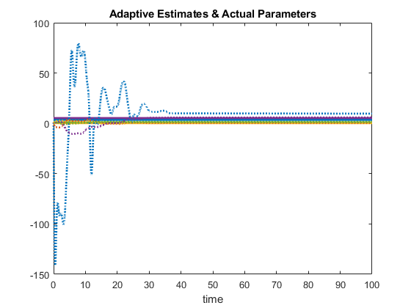

1. Plot of Parameter estimate errors:



**Controller 2:**

**Controller: $u=Y_{d}\hat{θ}+ μ_{2}$**

**Adaptation Law: $\dot{\hat{θ}}= γY_{d}{'e}_{2}+γY_{d}'tanh⁡(r)$**

1. List of Control Gains:

gamma =

700.0000 0 0 0 0

0 12.0000 0 0 0

0 0 0.5000 0 0

0 0 0 12.0000 0

0 0 0 0 0.5000

K = 5

a1 = 0.45

a2 = 0.5

beta = 0.9

1. Tracking error plot for each link:



1. Control input plot for each link:



1. Plot of the adaptive estimates:



1. Plot of parameter estimate errors:



**Third Controller:**

**Controller: $u=Y_{d}\hat{θ}+ μ_{2}$**

**Adaptation Law: $\dot{\hat{θ}}= γY_{d}{'e}_{2}+γY_{d}'tanh⁡(e2)$**

1. Control gains:

K = 5

a1 = 0.45

a2 = 0.5

gamma =

700.0000 0 0 0 0

0 1.5000 0 0 0

0 0 0.9000 0 0

0 0 0 10.0000 0

0 0 0 0 0.5000

beta = 0.9

1. Tracking error plot:



1. Control input plot:



1. Plot of adaptive estimates:

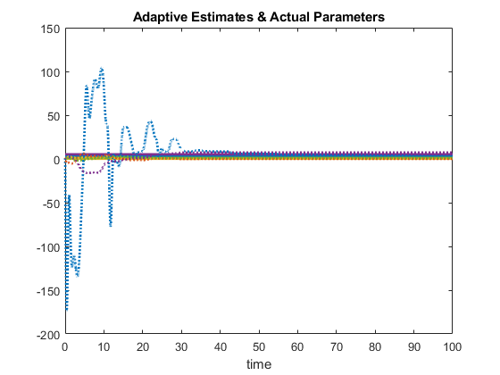

1. Plot of parameter estimate errors:

**Fourth Controller:**

**Controller: $u=Y_{d}\hat{θ}+ μ_{2}$**

**Adaptation Law: $\dot{\hat{θ}}= γY_{d}{'e}_{2}+sech⁡(t)$**

1. Control Gains:
   1. Gamma =

600.0000 0 0 0 0

0 20.0000 0 0 0

0 0 0.5000 0 0

0 0 0 30.0000 0

0 0 0 0 0.5000

* 1. K = 5
  2. a1 = 0.45
  3. a2 = 0.5
  4. beta = 0.9

1. Tracking error plot:



1. Controller input plot:



1. Adaptive estimate plot:

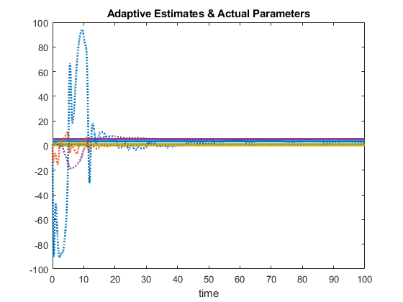

1. Plot of parameter estimate error:



1. **Discussion Section:**
2. Tuning adaptation gains had the most effect on the convergence of errors, control gains were tuned in order to improve the performance of the controllers.
3. Performance of tracking error increasing from standard adaptive controller to the ICL based adaptive controller.

 

We observe the errors converge at similar rate in all adaptations except second one where a second oscillation is observed before converging to zero.

Convergence time for controller:

*Controller 1: 35s*

*Controller 2: 75s*

*Controller 3: 32s*

*Controller 4: 44s*

Slowest convergence in second one and fastest convergence in third one.

1. Performance of adaptation for each case:



Here, we see that controllers are bounded, errors converge as well as parameters, however, there is some steady state error for one of them. While tuning gains, we get either underdamped parameters that don’t converge fast enough or the one that converges with some steady state error, the one with steady state error has been chosen.

steady state error = 9.6



Here, we observe a higher number of oscillations and poorer steady state error.

Controllers are bounded and errors converge to zero. Performance of this controller is inferior to the first one.

steady state error = 6.8



In this controller, a lower steady state error is observed as compared to first and second ones. It reaches steady state at a relatively similar rate as first controller (around t = 32s). Performance of this controller is best of the three. steady state error = 3.8



Here we see the oscillations damp out faster than the previous controllers. However, they reach steady state slower in comparison (around t = 43s) with steady state error = 4.1

Differences in performance of controllers are noticeable but not significantly different with third controller performing the best and second controller performing the worst of all four.

Other Observations:

* Simulated results of the four controllers are in accordance with the expected performance from analysis
* Adaptations based on r performed poorly (or needed better tuning) as compared to the ones based on e2
* This performance was achieved by using following percent of max torque by

Link 1 Link 2

* + Controller 1: 2 % 13%
  + Controller 2: 2% 10%
  + Controller 3: 2% 10%
  + Controller 4: 2.4% 16%
* The simulated performance of the four controllers resembles closely to the expected one from analysis.
* Third controller performs the best using the least percent of max torque among all four.
* In terms of computational effort, second controller takes a while to converge thereby requiring more computational effort while rest have similar requirements
* In this simulation we got to see how ‘r’ based adaptations perform when compared to ‘e2’ based ones. Also, we got to see how addition of hyperbolic functions to adaptations alter its performance.